Math 61 Learning Unit 2 Hand-In Assignment for Section 3.4
© Problems copyright Stefan Waner 2015 All rights reserved

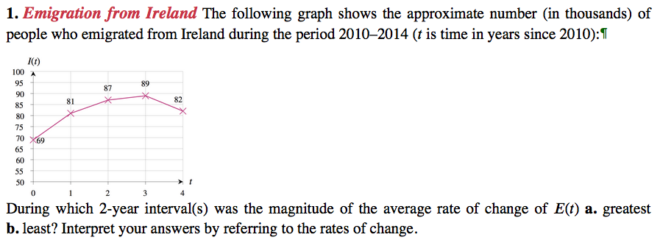
¶ Source: European Migration Network Ireland http://emn.ie.
Hint: See Section 3.4 Exercise 31 for a similar problem in the book.
- From the graph, the highest emigrated people from Ireland 2010 to 2012.
The magnitude of changes will be given by $\frac{change of E}{change of time t}$

$$\frac{87000-69000 }{2}$$
9000
- The least emigrated people from Ireland 2010 to 2012
The average change =$\frac{change of E}{change of time t}$
$$\frac{89000-81000}{2}$$
=4000
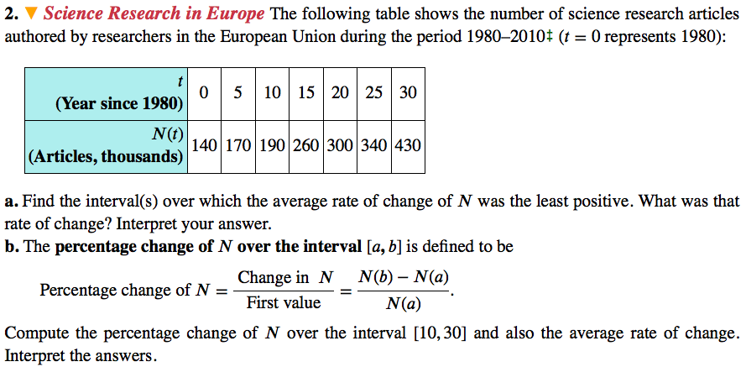
‡ 1980 data estimated. Source: http://www.sciencewatch.com
Hint: Similar to Section 3.4 Exercise 33 in the book.
- 2005 – 2010
- $\frac{430-340}{5}$ = 90/5 =18
$$Type equation here.$$
18 / 340 x100 = 5.29%
(430-190)/(30-10)
240/20
12
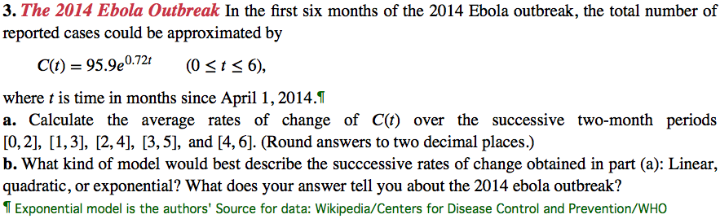
Hint: Similar to Section 3.4 Exercise 45 in the book.
- C(t) = 95.9e^{0.72t} when c=5 95.9e^{0.72 x5} =3509.77
- $c^{'}$(t)= 95.9 x 0.72 e^{0.72t}
$c^{'}$(t)=69.04 e^{0.72 x5}
$c^{'}$(t)=69.04e^{3.6}
$c^{'}$(5)= 2527.034
It is exponential because in 2014 higher increase cases increase of outbreak out of Ebola.
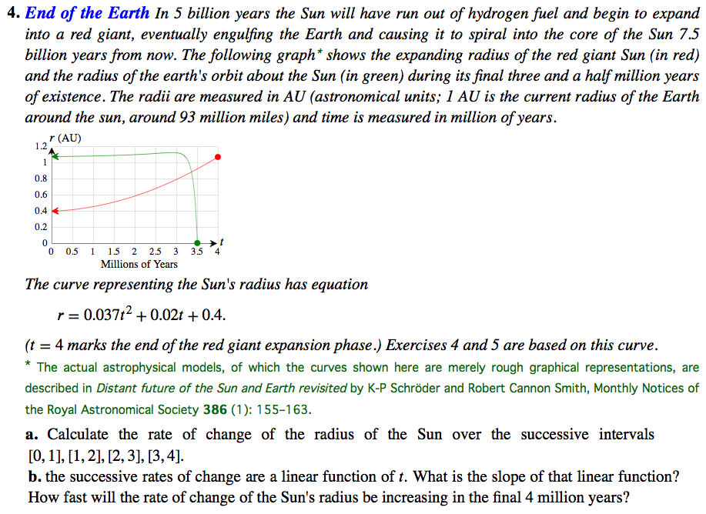
- Rate of change (0,1)
(0.45-0.4)/1 = 0.05
Rate of change (1,2)
(0.6-0.45)/1 = 0.15
Rate of change (2,3)
(0.8- 0.6)/1 = 0.2
Rate of change (3,4)
(1.1-0.8)/1= 0.3
b. r’ = 0.074t +0.02 when t = 4 milion
r’ =0.074 x4 +0.02 =
0.316 x 1000,000
316,000

